# **Name: Abdurrahman Qureshi**

# **Roll No: 242466**

Practical No: 8

Date Of Performance: 26/09/2025

Aim: Understand Docker Architecture and Container life cycle, install Docker Commands and execute docker commands to Manage Image and Interact with Container.

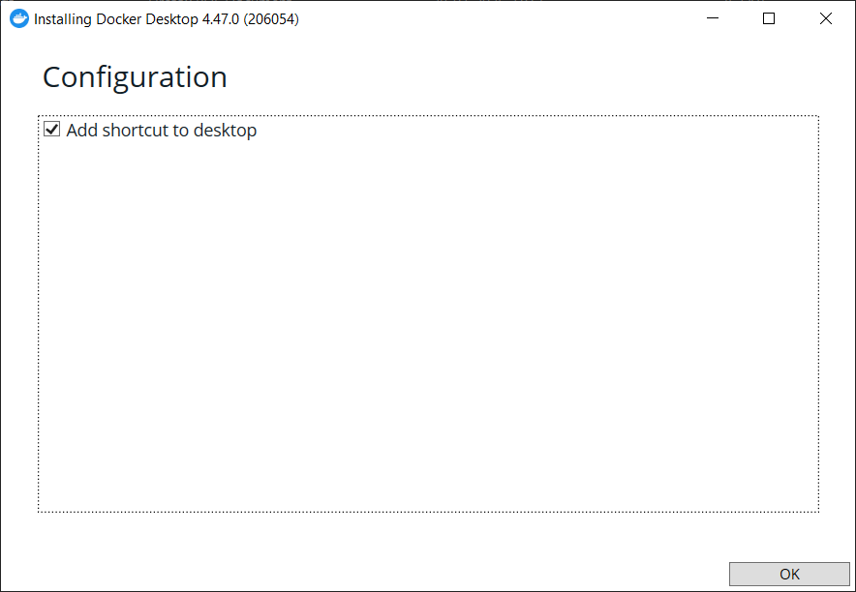

Configuring Docker Desktop

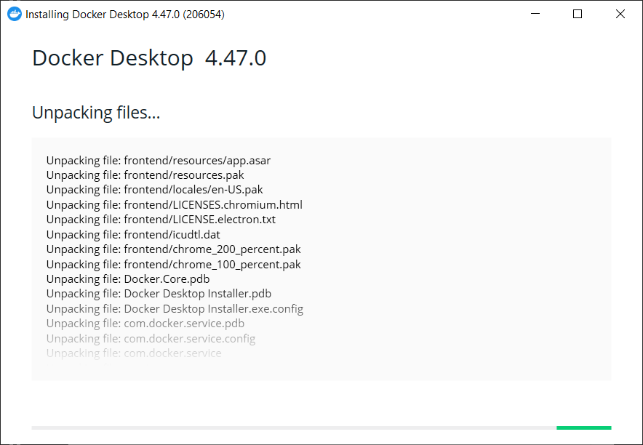

Unpacking Docker Desktop Files

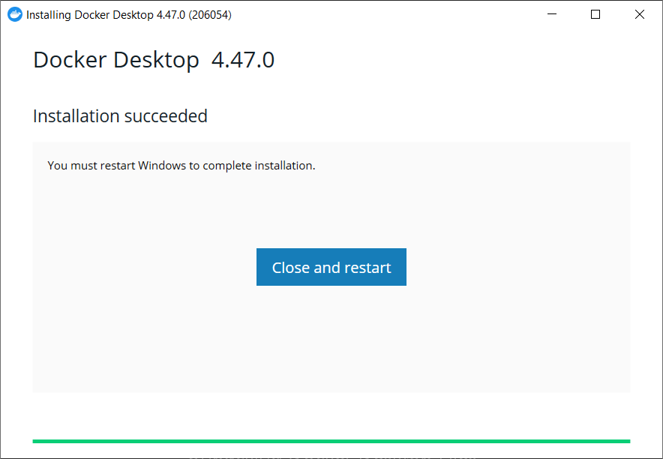

Docker Desktop Installation Successful



Accepting Docker Terms of Service

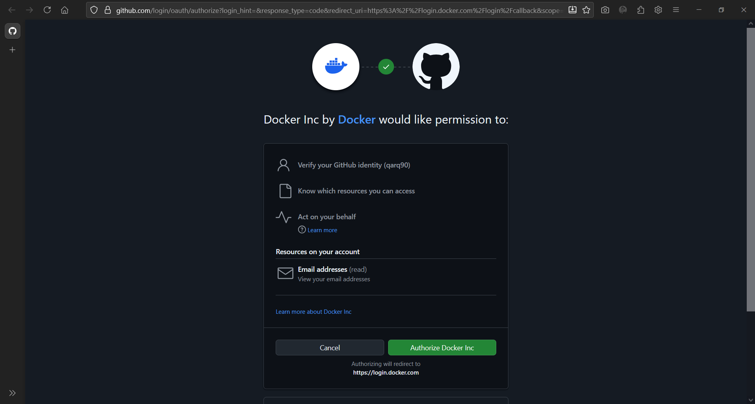

Logging via Github

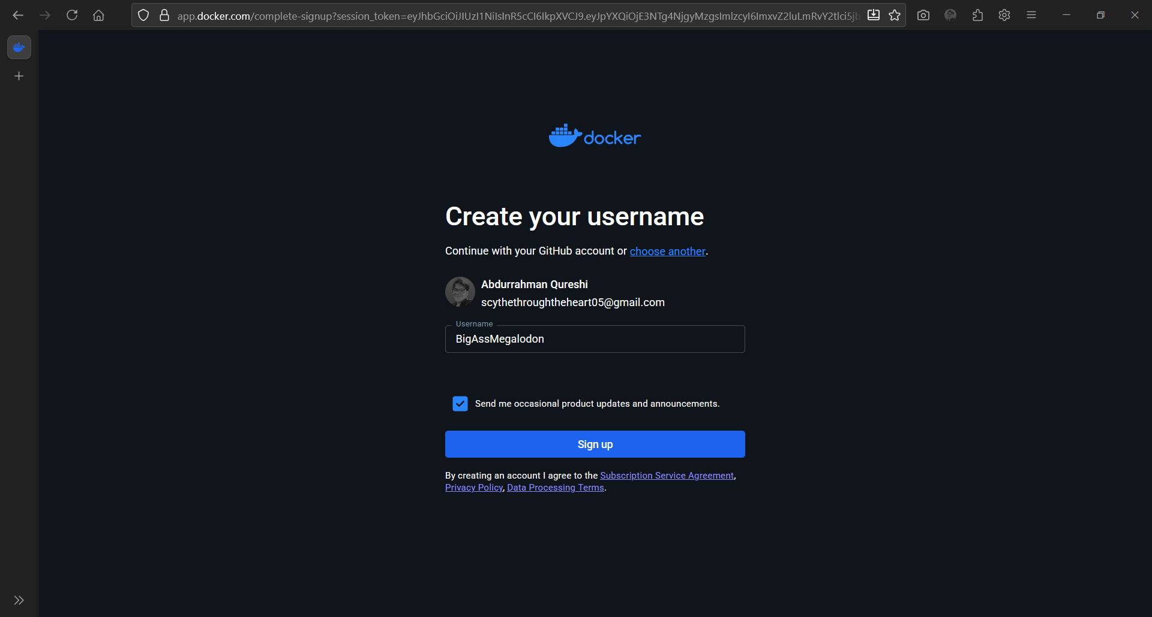

Creating new username

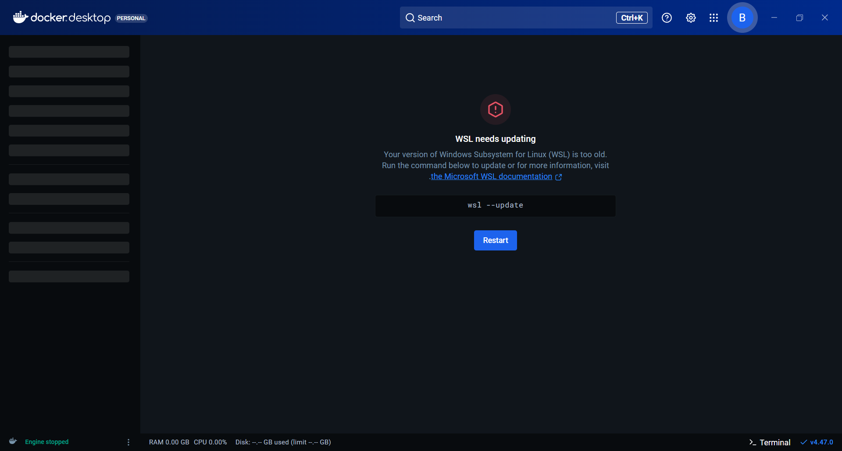

WSL update needed

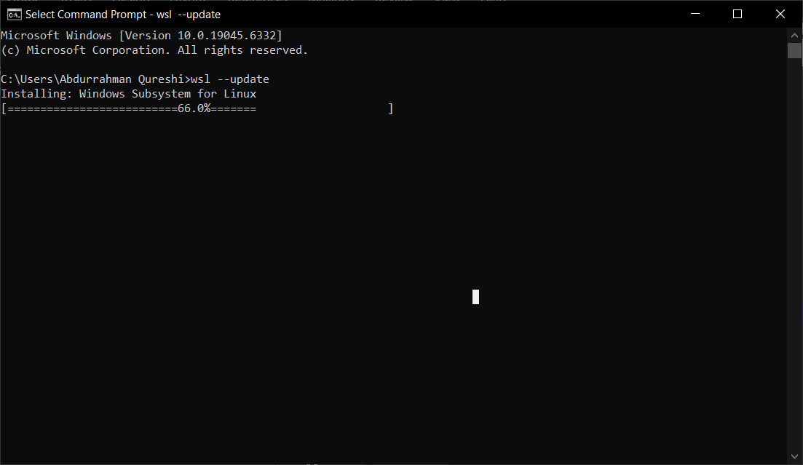

WSL updating

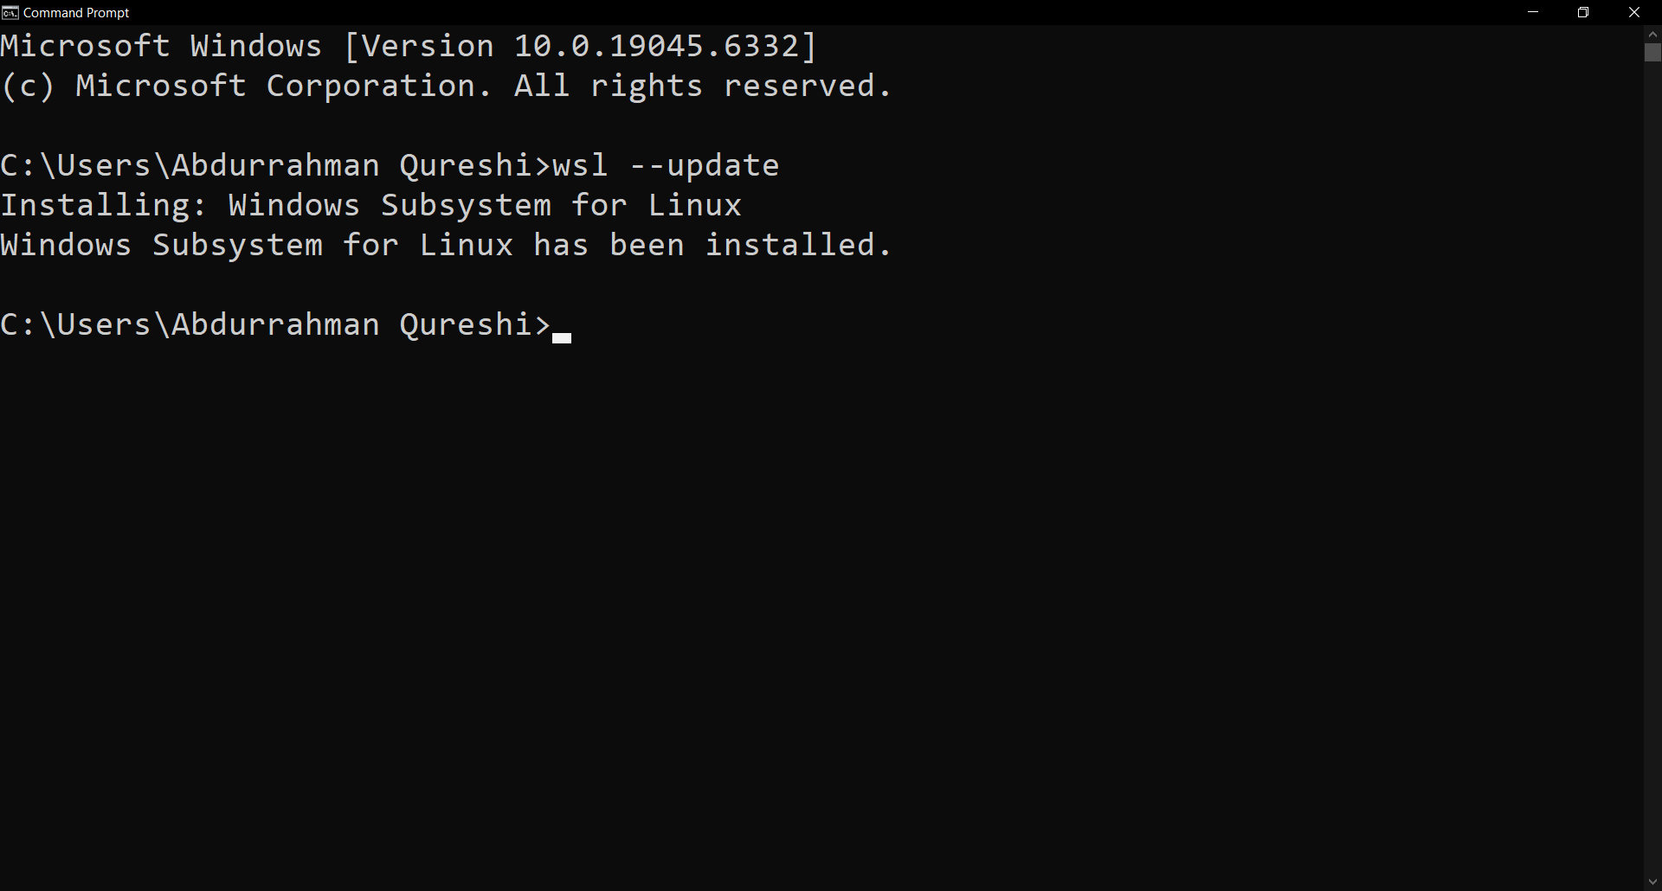

WSL updated successfully

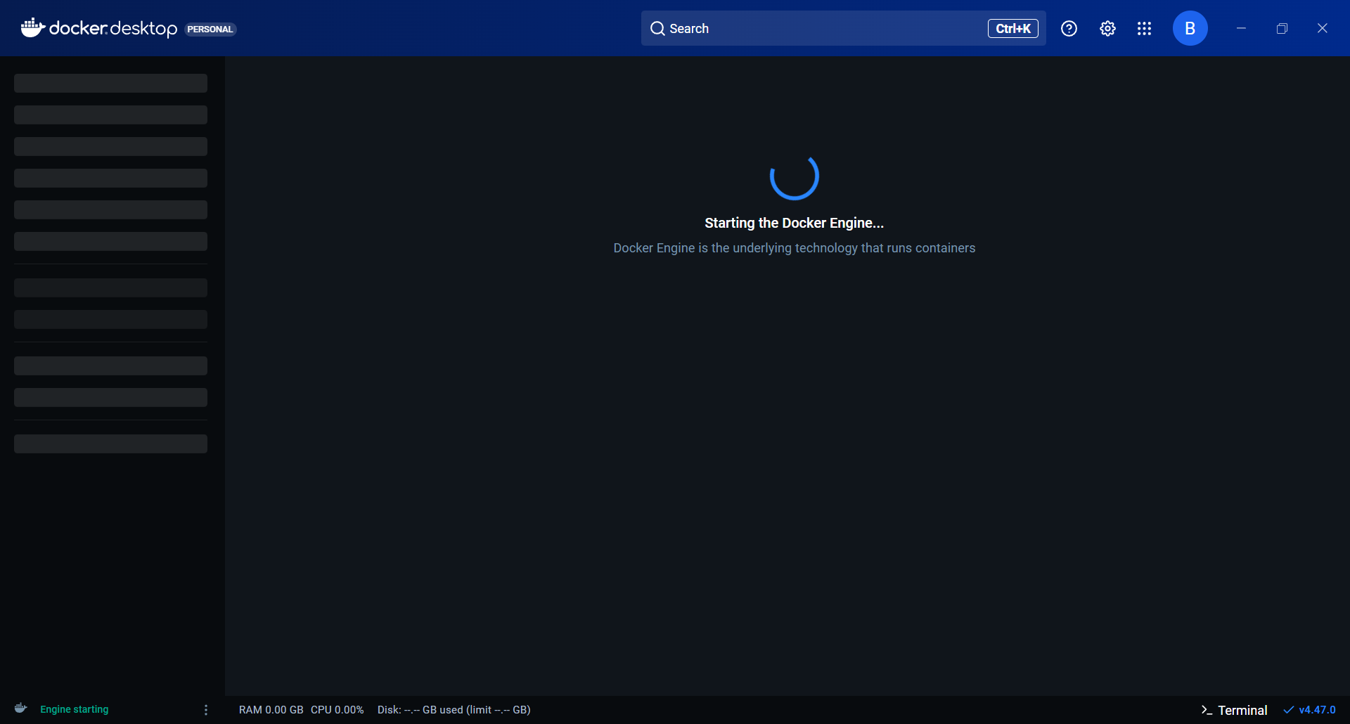

Restarting Docker Desktop

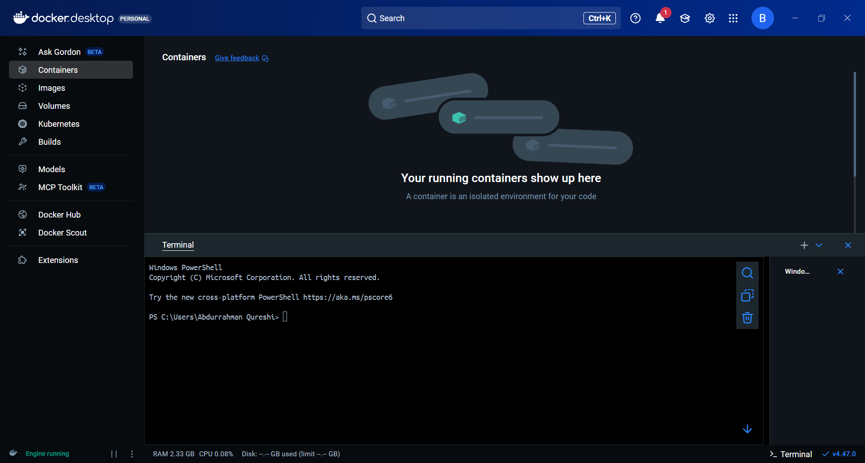

Home Page

1. **Pull an image from Docker Hub:**

docker pull [image_name]:[tag]

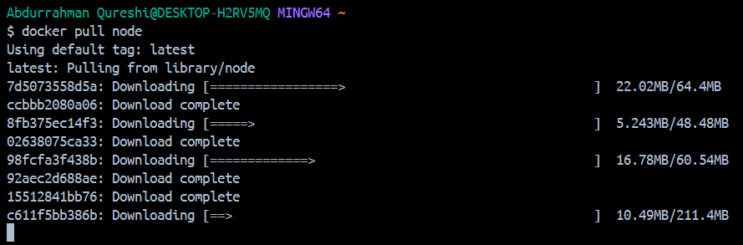

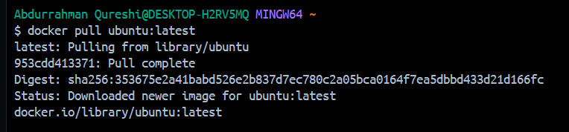

1. Run a container:

docker run [options] [image_name]

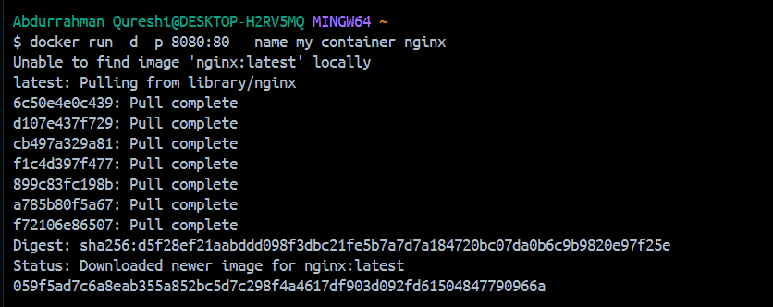

Output of nginx image:

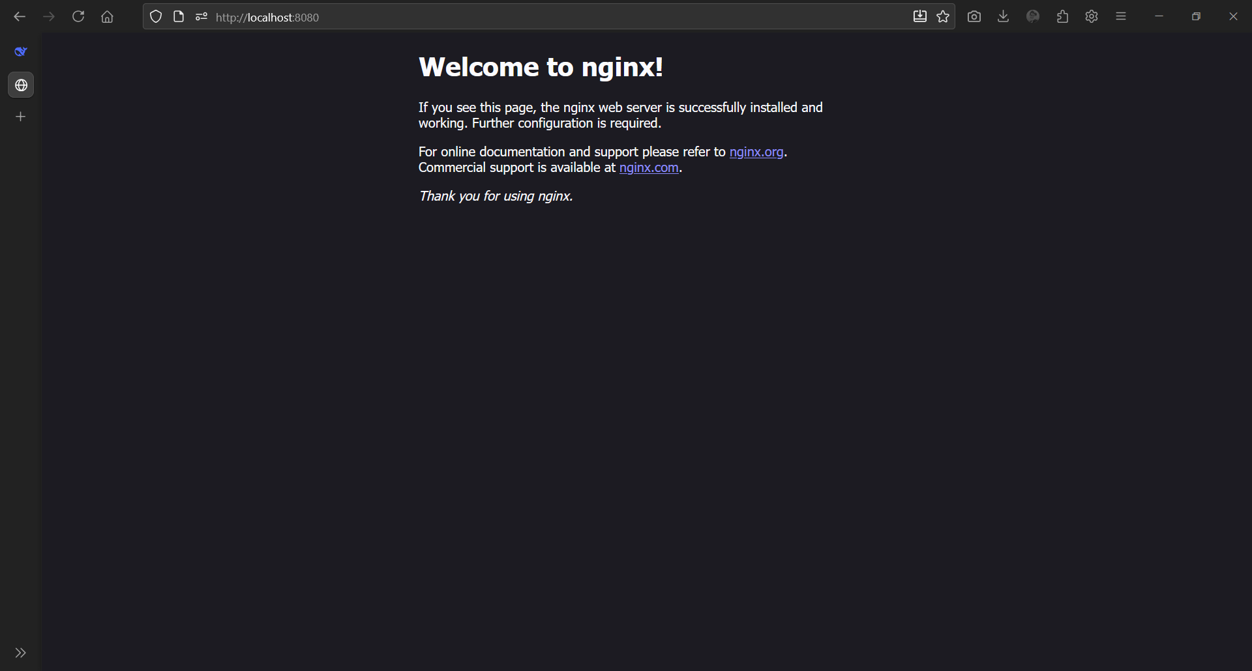

1. List running containers:

docker ps || docker ps -a



1. **Stop a running container:**

**docker stop [container_name_or_id]**

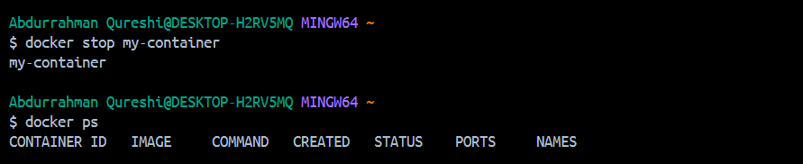

1. Start a container:

docker start [container_name_or_id]

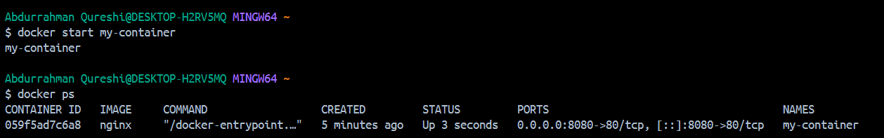

1. **Remove a container:**

**docker rm [container_name_or_id]**

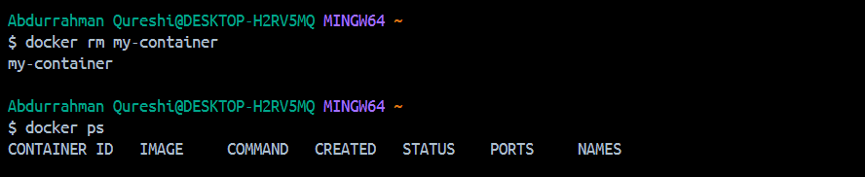

1. **List images:**

docker images || docker images -a

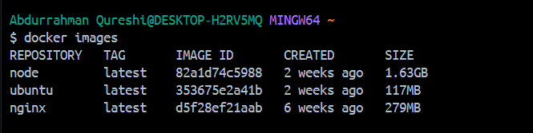

1. **View container logs:**

docker logs [container_name_or_id]

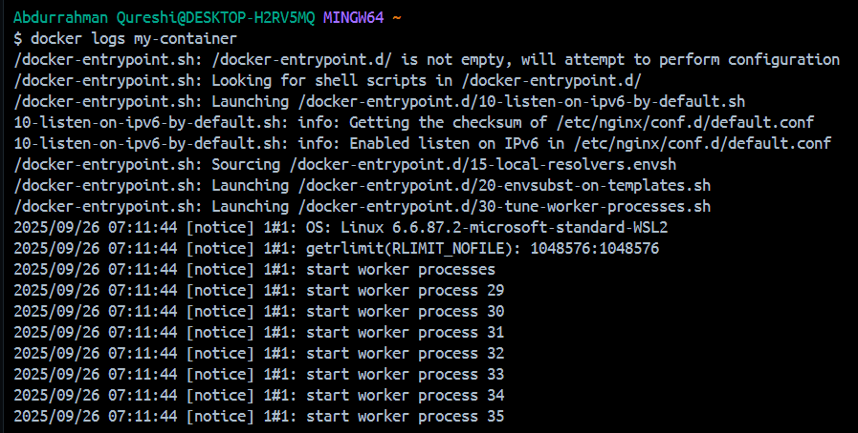

1. **Execute command in running container:**

**docker exec [options] [container_name] [command]**

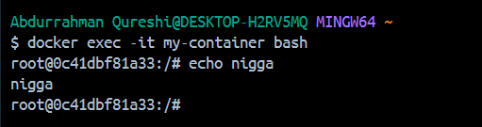

1. **Show information:**

**docker info**

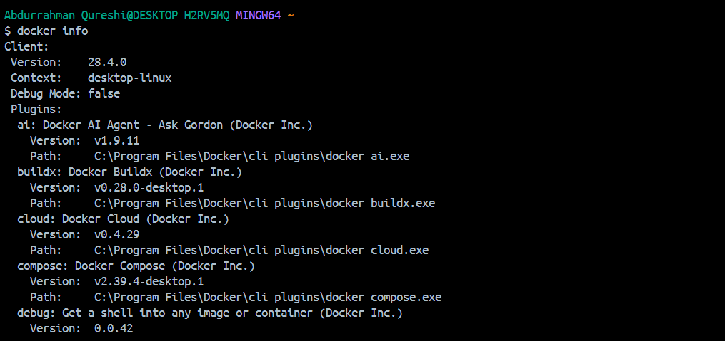

1. **Show Version:**

**docker version**

